|  |  |
| --- | --- |
| **Digital Forensics**  Diploma in CSF/IT  Year 2/3 (2022/23) Semester 4/6 | Week 3 |
| Tutorial 3 |
| **Case Study: Investigating Lateral Movement** | |

**OBJECTIVES**

After completing this topic, you should be able to

1. Explain how the logon events are created
2. Identify the location where these events can be found

**Background:**

In a compromised Windows environment, attackers typically leverage stolen, valid credentials (either local or domain) to move from system to system – a process known as “lateral movement”.

Many environments use common local administrator passwords for all systems, or subsets of their environment. If an attacker compromise a single system and obtain such a credential, they can move freely from host to host. Worst yet, if the attacker gains access to a domain administrator account, they may be able to access any system within the domain at will.

**Case Description:**

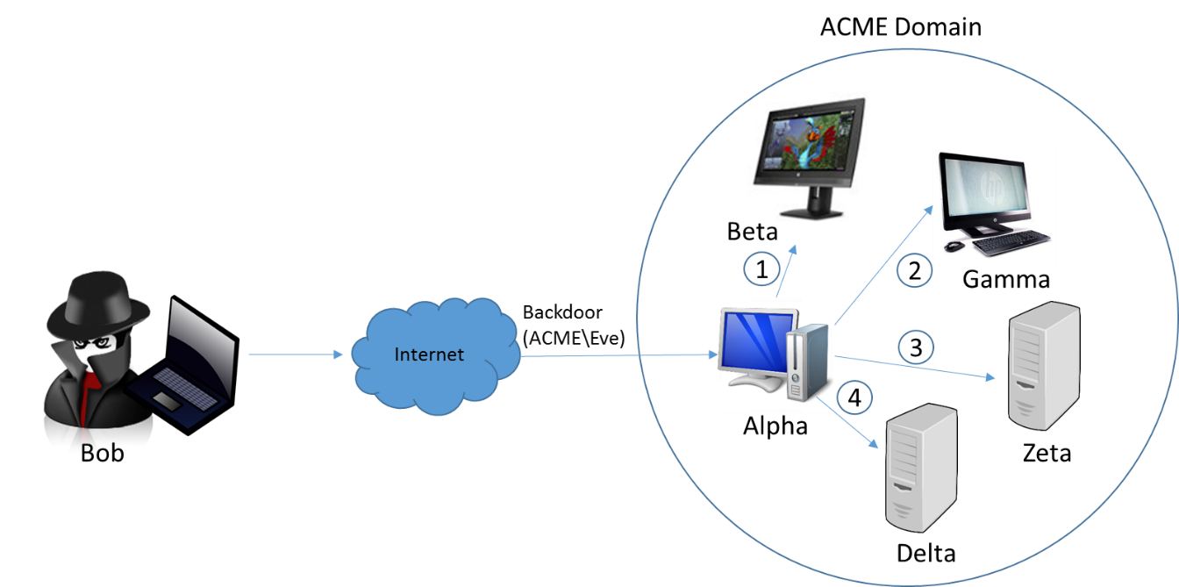

* The attacker, Bob, has interactive access to a Windows 7 workstation, Alpha, through persistent backdoor.
* Alpha is joined to a corporate domain, ACME.
* The backdoor runs under the context of the domain user who owns Alpha, ACME\Eve.
* Through password dumping and other intrusion activities, the attacker has obtained credentials for two accounts:
  + A local administrator, localAdmin, that is configured with an identical password on each workstation in the ACME domain
  + A domain administrator, ACME\domainAdmin, who has full access to all workstations and servers in the environment

Bob uses the backdoor to invoke a command shell under the context of ACME\Eve. He uses various commands, in combination with the credentials for accounts localAdmin and ACME\domainAdmin, to access four systems, each in a different manner:

1. He mounts the C$ share for workstation Beta, from source system Alpha, to transfer malware and tools, using the following command:

net use \\beta\c$ /u:localAdmin “badPassword”

1. He uses the SysInternals PSExec utility to remotely execute a command on workstation Gamma, once again from source system Alpha, using the following command:

psexec.exe \\gamma –u ACME\domainAdmin –p worsePassword “C:\path\to\malware.exe”

1. He establishes a remote desktop connection to server Zeta, once again from source system Alpha, using the Windows built-in RDP client (username ACME\domainAdmin, password worsePassword).
2. He browses to an IIS intranet web server, Delta that requires NTLM authentication. Bob uses ACME\domainAdmin credentials.

**Activities:**

Q1: Research online to find out the purpose and syntax of the following commands:

|  |  |  |  |
| --- | --- | --- | --- |
| **No.** | **Commands** | **Purpose** | **Syntax** |
| 1 | net use | To map a drive letter to a remote share / server | Net use \\computername\sharename /user:domainname\username  password  Note: C$ is one of the hidden shares on a Microsoft network  Hidden shares are not visible when viewing another computer’s shares. However, it is still accessible if the name of the hidden share is known |
| 2 | psexec | Windows Sysinternals –To execute processes on other systems | *Psexec* *\\computer* *-u user -p psswd cmd*  -u -> Specifies optional user name for login to remote computer  -p -> specifies optional password for user name  Cmd -> name of application to execute |

Q2: Each of the four actions carried out by attacker Bob above will result in a logon event. Complete the following table to show the Logon Type (refer to Lecture 3, slide 47) and the location where the events are logged.

|  |  |  |  |
| --- | --- | --- | --- |
| **Action** | **Logon Type** | **Location** | **Remarks** |
| 1 | Type 3 (network) | Beta | A local account was used |
| 2 | Type 3 (network)  - “logon attempt using explicit credentials event (EID 4648) | - Gamma and ACME domain controller  - Alpha | - A domain account was used  - Due to the use od Psexec under a different set of domain credentials than the attacker’s current session (ACME\Eve) |
| 3 | Type 10 (RemoteInteractive) | Zeta and ACME domain controller | A domain account was used |
| 4 | Type 3 (network) | Delta and ACME domain controller | A domain account was used |

- End -